Alex Mekovsky
COSC 320
Enyue Lu
3/26/2023
Lab 06 Report
Lab Report: I have successfully completed all tasks required for this lab. I was able to get both the set and the map code working and display both successful and failed results. Here is the first part of the lab focusing on sets.
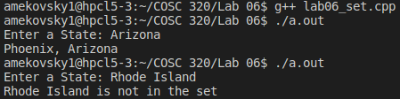

Here is the second part of the lab focusing on maps.

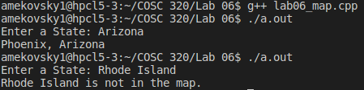

Overall the coding of the lab went relatively smoothly, I had some issues implementing the insert functions of the sets and maps, however I was able to successfully fix these issues, and the lab proceeded as normal. Overall the lab took me about two hours to complete, and other than the issues with the insert functions of both parts, there were no other issues with completing the lab.

